# Lab: SID

|  |
| --- |
| * This is worth 10 points and due tonight. * Follow the usual naming convention. Place your answers on the separate tasks file and submit it. DO NOT use this file for submission. * Please **zoom in** your screenshots. |

# Task 1: Getting SID, SAT in Windows

* Obtain the SID of the current login with **WMIC** command. Attach a screenshot for the SID and highlight it in red/yellow.

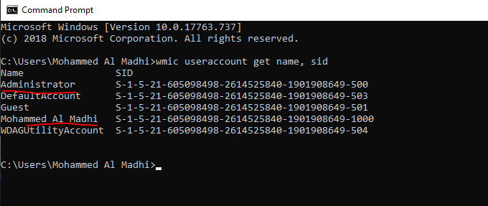

* Obtain the SID of the current login in the Registry. Attach a screenshot for the SID and highlight it in red/yellow.

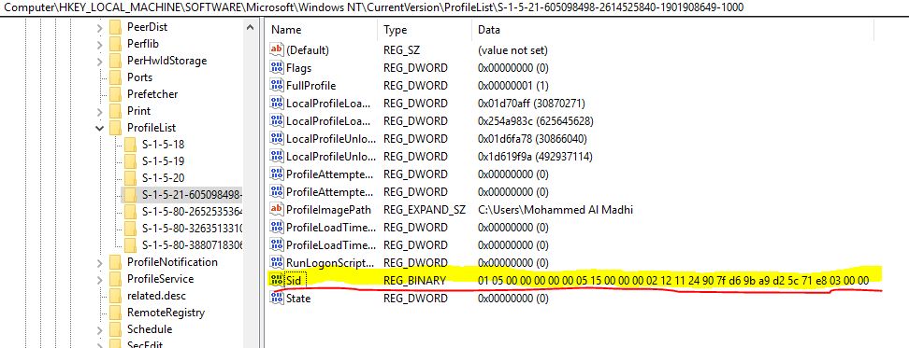

# Task 2: Getting SID in SQL Server

* Get the SID of the account you used for SQL Server login.
* A. SID: 0x01050000000000051500000002121124907FD69BA9D25C71E8030000.

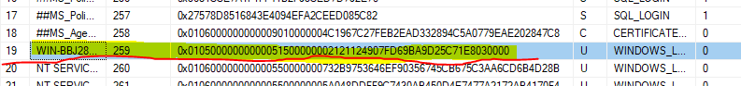

* B. What is the role of the function “fn_SIDToString” in the above?

The purpose is to change the value of the SID integer to string value such as “S-“

* C. Show in screenshots that the SID from SQL Server for the administrator login and that from Windows Server are the same. Compare the SIDs in a string format (not binary).

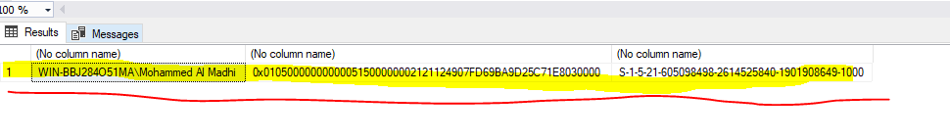

Can confirm both are the same based on the values given.

* D. SID: 0xFF789A7BFDC53444A6A6E7BA3EF6514F

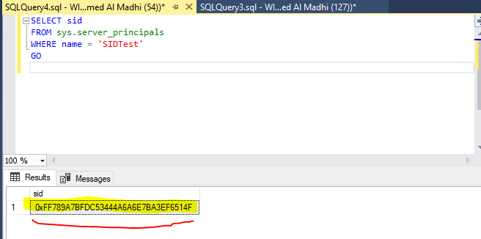

* E. SID: 0xD66D85255921D847BAD0EACD3B7A7E5E.

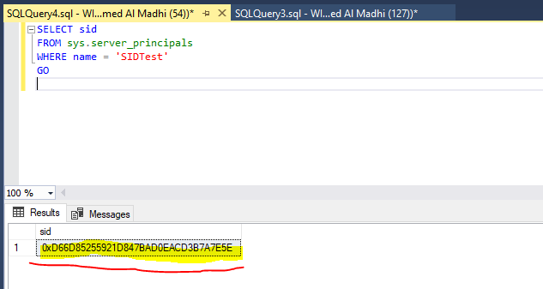

* F. Are the SIDs of login SIDTest the same? Describe the reason why they are (not) the same?

They are not the same, when the first one was dropped the SID value is also deleted. When a new login is created a new SID is given.

# Task 3: Learn PowerShell Scripting

* Run your script and report the output in a screenshot.

